Making sense of sensors

Definition:
Sensors are objects that provide information to players about objects.

Some preliminary thoughts, disguised as a FAQ:
- Might Sensors mask the information about objects on one’s own team? This seems to be a requirement, not so much for the purpose of masking friendlies from each other (although that might be a capability desired by some experimenters) but because if one’s friends are never masked then anything that is masked must ipso facto be an enemy.
- What do sensors sense? What is available for sensors to sense would be values of attributes of objects.
- Why more than one type of sensor? Different sensors can detect different attributes.
- How are sensors combined? For each attribute of an object, the sensing capabilities of a player are the maximum of those currently provided by all sensors controlled by that player.
- What is the mapping between sensors and attributes? This will be n: 1 – many sensors may be capable of providing information about a particular attribute, but a given sensor only responds to one particular attribute. There will be ‘sensor arrays’ that are combinations of individual sensors. This simplifies the definitions without limiting capabilities
- Can sensors from different players be combined? Yes. Players belong to sensor networks, and a player has access to all the information known to any player in a sensor network.
- Can there be libraries of types of sensors? Yes, but later.
- What does an object ‘know’ about what sensors can detect about it? An object knows nothing about individual sensors or their capabilities. The object does define, statically, various levels of how clearly it can be detected.
- What can an object do about sensors? There are no energy damping fields, shields, or chaff that can be deployed. The detectability of an object can change with its state.
- What does a sensor ‘know’ about what it can detect? Each sensor has a set of 3-D shapes called ranges; a range defines how well the sensor can distinguish its attribute.
- What does an attribute know about what sensors can detect? See the answer to “What kinds of intermediate capabilities might sensors have.”
- What kinds of intermediate capabilities might sensors have? For most attributes, what a sensor ultimately detects is a number. It’s hard to detect part of a number, but does make sense to detect a number with a certain degree of fuzziness. Fuzziness is easily instantiated by placing a probability distribution on the value.
- Where is the fuzziness distribution defined? Fuzziness could be inherent in the characteristics of the signal (hence, defined with the attribute) or with the characteristics of the sensor (hence, defined there), or both (but let’s not go there); given that our goal is at most middling fidelity, the advantage of defining it with the attribute is that it needs (and can) only be defined once. Sensors can still differ in their ranges (sensitivity), so this is not a serious limitation on experiments.
- How is fuzziness manifested? Since fuzziness is imprecision in the signal, the different fuzziness indicators can be taken to be the variances of normal distributions whose mean is the intended value. (This isn’t hard to calculate; if the z-transform is used, the actual values can be derived from tables.) Some limited number of fuzziness levels, woulkd be defined with each detectable attribute.
- How is fuzziness sensed? The sensor capability is then defined as a mapping of regions to fuzziness level (1-‘5’). The default for each attribute would be 100% -- expressed as a ‘five’ level scale on which each of the (variance) values is 0. Each region is a cone centered on the sensor, and is defined by three numbers, the angle of spread, the radius, and the direction (of the axis of the cone). Regions are not necessarily nested, so for each location in space the fuzziness of the observation is the smallest (clearest) of all possible regions.
- What about fuzziness in non-numeric attributes? The non-numeric detectable attributes fall into three categories: triples, strings and the icon of the object. Fuzziness on triples can be implemented by applying the fuzziness distribution to each component – the physical type of the object will indicate whether the z-coordinate is variable. For strings, fuzziness (if desired) causes the probabilistic replacement (if a random number between 0 and 1 is greater than the fuzziness number) of one letter with another in each position; this could be used, for example, to mask the type of detected object. For the icon, the easiest adaptation would be for the ‘fuzziness’ level to indicate a particular replacement icon, that will have been downloaded as part of the icon definition file. A different approach would have each fuzziness level defined as a distribution over the set of all icons.
- When does the fuzzy value change? It will certainly have to change when the object passes from one detection zone to another (for each sensor). Since recalculation is thus possible at every tick, the value might as well be recalculated on every tick, adding a pleasing verisimilitude to the notion of fuzzy detection – a fuzzy value would be seen to fluctuate on the screen.
- Can sensors be destroyed? No. Sensors are attributes of units. However, sensors can be state-dependent.
- Can sensors be blocked? Yes. Sensors will be blocked by active regions, which will be defined later, most likely as polygonal regions with heights. Active regions will have blocking characteristics relative to each ‘genus’ of sensor. Blocking might be defined as a multiplier in [0,1] applied to the radii of a sensor.
Other notes
- Kinds. There are certain basic types of sensor, differentiated by method of propagation and ways that the sensors can be blocked. These, like genera of units, will be hard-wired. Initial types: Visual, radar, sonar, auditory (?).
- Complexity: There is really a lot more flexibility and complexity in the scenario language than anyone could use effectively, although each particular instance is (or should be) arguable for some particular situation or type of experiment.

Illustration
The figure below illustrates these ideas.

On the left there is a tank and, although they are not centered on it (for legibility), also given are the fuzziness definitions for two attributes, one numeric (50) and one a string (MX417W). Fuzziness level C gives 100% accurate rendition, but B and A each allow variance. On the top on this side are the shapes of the probability distributions for the numeric value at each of the two fuzziness levels; below it is an example of how the string might have been garbled at each level.

On the right is a representation of the range rings for a sensor array: the outermost circle achieves detection with fuzziness level C, the next with B, and the innermost with A – outside the third level there is no detection at all. Each of the attributes will have been detected by a separate sensor, and there is no particular reason why the two sensors have to have the same radial rings.

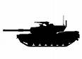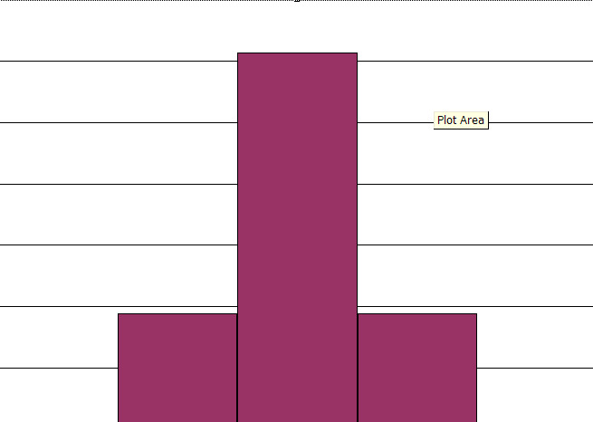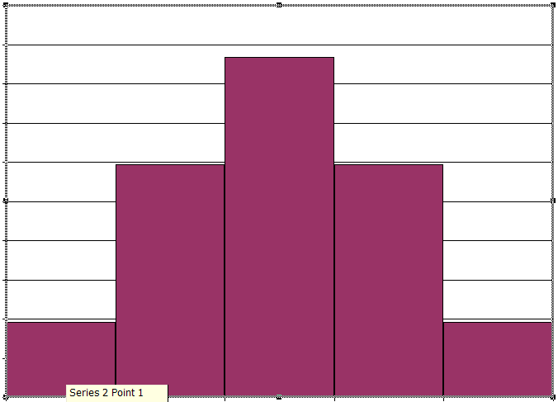
Fuzziness
A
VX4A7W
MX417W
VH11PK
Distance
C
B
A
B
C
undetectable
50
Correct value of string attribute
Correct value of numeric attribute

Implementation:
Some possibilities are:
  - Use a ViewPro, one per GUI, to calculate all the viewing information for all objects, based on all sensor networks to which player belongs.
  - Have a server-based ViewPro do all the calculations, and distribute them to individual ViewProlets on individual player machines.
  - Spawn a thread for each sensor network. These threads calculate the views of what they can see, and distribute to ViewPros on individual machines, which combine the results from all the sensor networks that include the player.

Sorry; the devil made me do it
The distribution of error typically follows a normal distribution
The algorithm, which seems reasonable, is to associate each fuzziness level with a threshold; if a random number exceeds the threshold – on a character-by-character basis – the character is replaced. Replacement is by (uniform) random selection among all possible characters.

